Korea
會資一乙第二組
62 Han Ting 62 Jane 64 Sandy 67 Gina 79 Hank
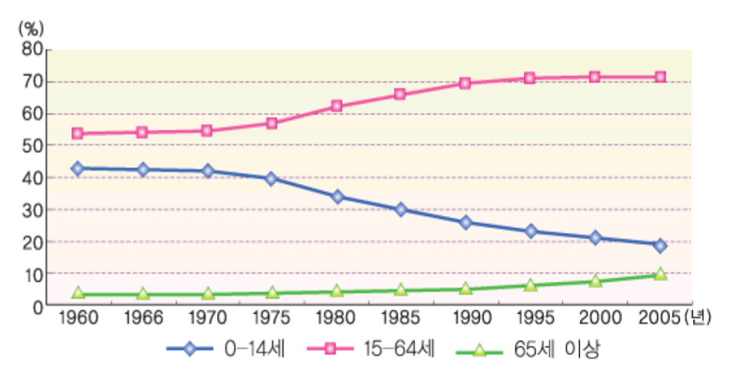
Population

Since 1990,the 「annual population growth rate」of Korea is less than 1% and down to 0.5% in 2000,it is a typically less birth and death country

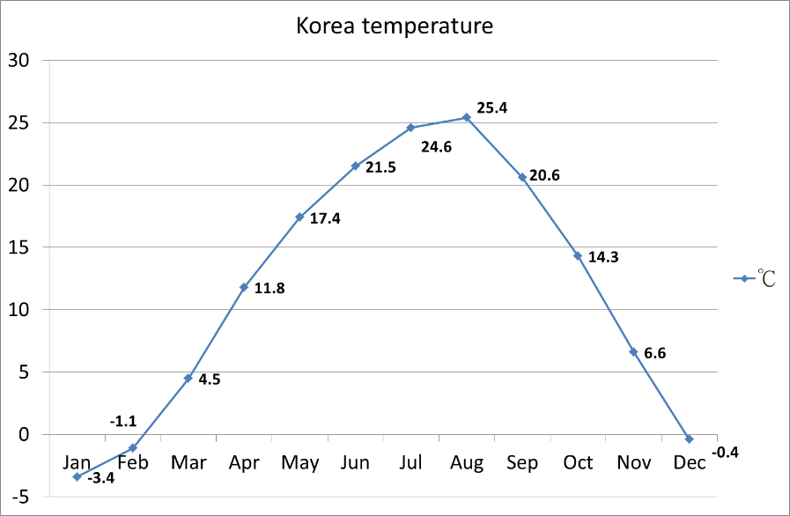
Weather
Korea has a temperate marine climate, it's four seasons distinct, spring and fall are short! It's hot in summer and cold in winter!

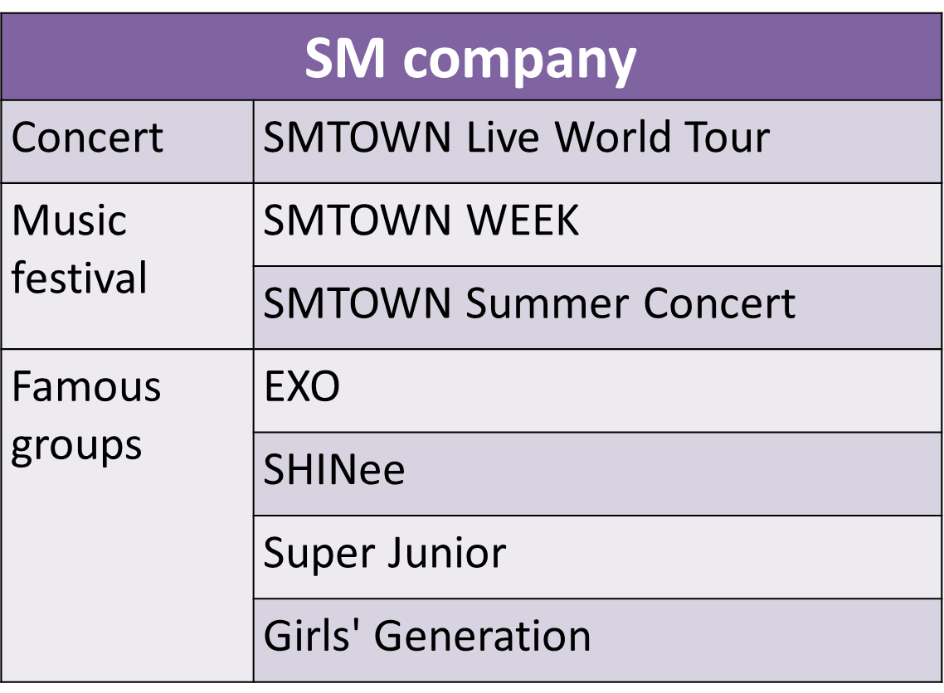
SM Company

SM each concert has at least thirty thousands of fans. Music festival just like the marathon of singing concert lasting for 8 days each time

