Handout of Our Presentation
Group: Third group
Members: John, Covey, Candy, Kevin, Tony
Country: the U.S. / America

- Introduction by John
(about 30 seconds)
- Background of the Country by Kevin
Political surroundings
Geography surroundings
Demography surroundings
Religions (about 3 minutes)

multi-ethnic 多種族的
Constitution 憲法；章程，法規

- Economic by Tony
Imports & exports
Main Growth of the U.S.A economy
(about 3 minutes)

- Agriculture by Covey

(about 3 minutes) 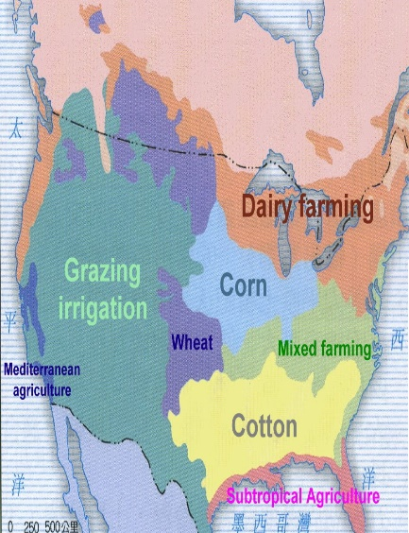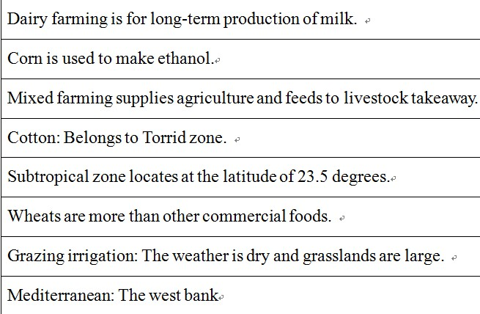

Ethanol 乙醇 | Subtropical 亞熱帶
Torrid zone 熱帶氣候 | Mediterranean 地中海

- Representative company – Monsanto
by Candy
Brief introduction of Monsanto (about 5 minutes)
History
Technology
Positive influence & Negative influence toward societies

polystyrene 【化學】聚苯乙烯 | Roundup 召集；集攏
Synthetic 綜合（性）的 | Pesticide 殺蟲劑
Headquarter 企業總部 | Dilemma 困境；進退兩難

- Conclusion by John
(about 30 seconds)
- Q & A

