Netherlands
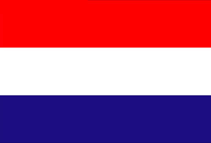
Group 4：11 Tracy、06 Sophia、10 Patty、18 Stanley、22 Brad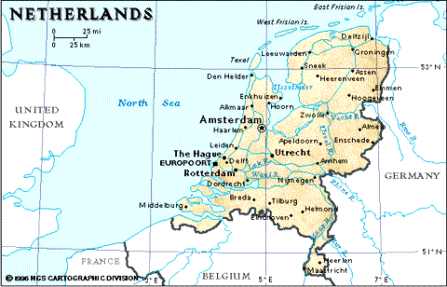

Language | Dutch
Capital | Amsterdam
Population | 6.1 million
Geography | 7,494 square kilometers(land and water included)  5,488 square kilometers (land alone)
Weather | Ocean climate country, westerly, often rains
Politics | Constitutional monarchy 君主立憲制
Currency | EUR 歐元
stereotypical images | tulips, windmills, clogs, cheese and traditional dress (klederdracht)

