Switzerland
- Overview of Switzerland
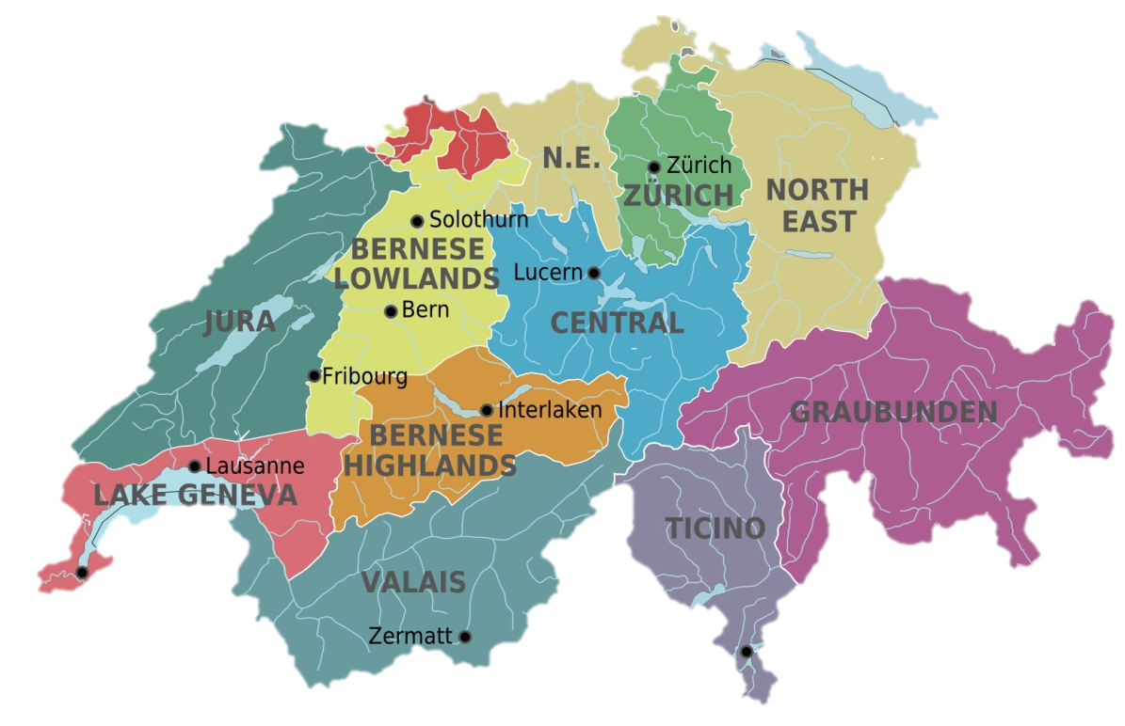
- Geography
- Capital - Bern
- Weather
- Population
- Official language
- Religion
- Currency
- Politics
- Festival
- Celebrity
- Famous story
- Food and Drinks
- Economy
- Organization
- Industry
- Famous corporation
- Representative company of Swiss - Rolex

名詞解釋：
Temperate continental climate 溫帶大陸性氣候
Romansh 羅曼什語
Catholicism 天主教
Protestantism 新教
Grand Slam singles titles 大滿貫單打冠軍
Frondue Fromage 起司火鍋
Emmental cheese 埃文達起司
Mariana Trench 馬里亞納海溝

