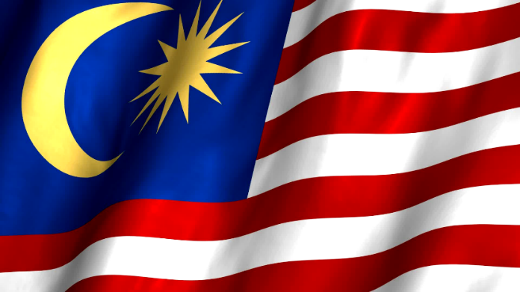
Group 7
Yee Fun (28)
Eddie (29)
Stanley (30)
Kevin (31)
Cynthia (32)

1 ringgit = around 8.09 Taiwan Dollars.
Malaysia united with North Borneo (北婆羅洲), Sarawak (砂拉越), and Singapore (新加坡) on 16 September 1963. In 1965, Singapore was expelled (逐出) from the federation (聯盟).

Malaysia has one of the best economic records in Asia (亞洲最好的經濟記錄之一)
In 2014-2015, Malaysia’s economic was ranked 6th in Asia (全亞洲第六名) and 20th in the world (全世界第二十名)

International trade (國際貿易) and manufacturing (製造)are the main industry in Malaysia.
Exporter (出口商) of natural and agricultural (農業) resources, and petroleum (汽油) is a major export. Palm Oil = 棕櫚油

Overall infrastructure (基礎設施) of Malaysia is one of the most developed in Asia, ranked 8th in Asia and 25th in the world. Ranked 19th in the world for its road quality (公路質量), port infrastructure (港口基礎設施) and air transport (航空運輸).

Crude Oil = 原油

Nasi Lemak: Malay fragrant rice dish cooked in coconut milk and pandan leaf, usually eaten for breakfast.
Laksa: Laksa consists of rice noodles with chicken, prawn or fish, served in spicy soup.
Satay: Satay is a dish of seasoned, skewered and grilled meat, served with a sauce.
Roti Canai: Roti Canaiis a type of Indian-influenced flatbread found in Malaysia, Indonesia and Singapore. It is typically sold by Muslims, most often with street carts, and is usually Halal*.
*Halal = foods without pork. (Because Muslims may not eat pork)

