G10 09 Jenny 22 Nini 23 Yourong 26 Lyon 30 Cindy
Belgium
Languages：60% Dutch, 40% French, less used by German.
Politics：is a constitutional, monarchy and a federal parliamentary *democracy.
Regions, Provinces and communities：
Three regions →Vlaanderen→ Five provinces
Wallonie→ Five provinces
Brussels capital
Three communities →Dutch community
French community
*German community
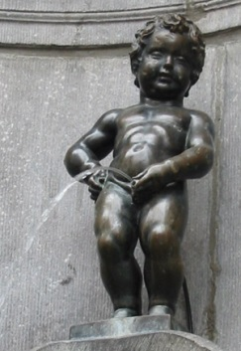
Population：59%Flamands, 41%Walons
Education : 6 to 18 years of age for Belgians.
Religion : Roman Catholicism
Currency : EUR
Kattenstoet : (Festival of the Cats) parade in Ypres.
It has been held regularly on the second Sunday of May.
Hot spot : Manneken-Pis

Economy
- One of the most developed industrial regions.
- Export is number one in the world.
industrial structure
service | 78%
industry | 21%
agriculture and aquaculture | 1%
- Taxation is one of the highest in Europe.

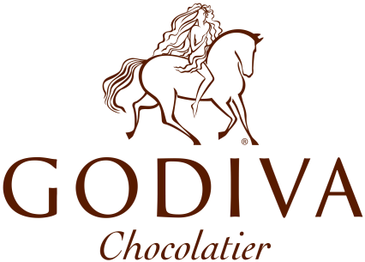
Company: GODIVA
Founded: 1926
Founder: Pierre Draps
Main Products: Chocolate

