Brazil
Geography
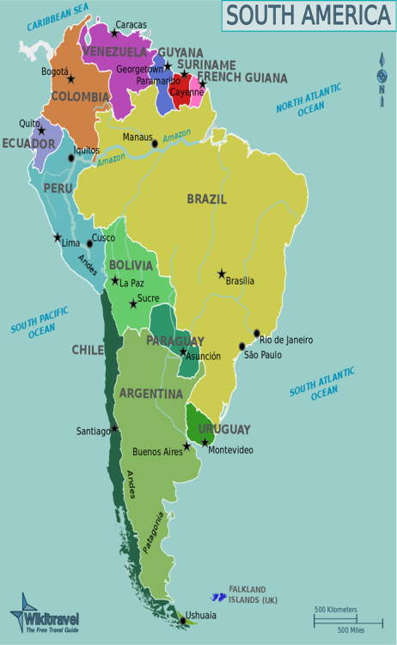

Population
- White
- Pardo
- Black
- Asian
- Amerindian
Weather
Official Language - Portuguese
Capital City - Brasília
Currency - Brazilian real (BRL)
Politics - Presidential republic
President - Dilma Vana Rousseff
Cultural Difference
- dry hair or not
- sense of time
- the way of greeting
Culture
- Carnival
- Football
Economy
Industry
- Coffee
- Tourism

Top 10 Tourist Attractions in Brazil
Agriculture
- Sugarcane
- Soybeans
- Corns
- Cocoa
Mining Industry - Iron ore
Technology - Embraer
Representative company - Havaianas

