Belgium
Introduction
- Motto: Strength through Unity.
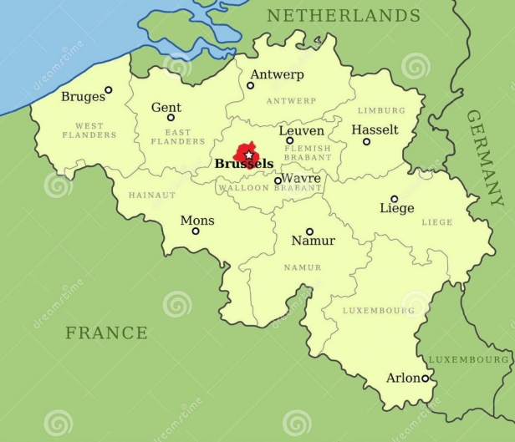
- National flower of Belgium: poppy (罌粟花、虞美人) and Azalea(杜鵑花)
Geography & Population
- capital: Brussels
- area: 30,528 km2
- population: 11 million
Weather
- winter average climate: 3 Celsius
- summer average climate: 17 Celsius
 | Official Languages
 | - French | - German
 | - Dutch
Festival |  | Tourist attraction
- Brussels Flower Carpet |  | - manneken pis
- Cat festival |  | - Atomium
The main export product
- petrochemical industry | - Automobile industry
- Diamond | - chocolate

