Sweden
Overview
- Part 1 (Sweden introduced)
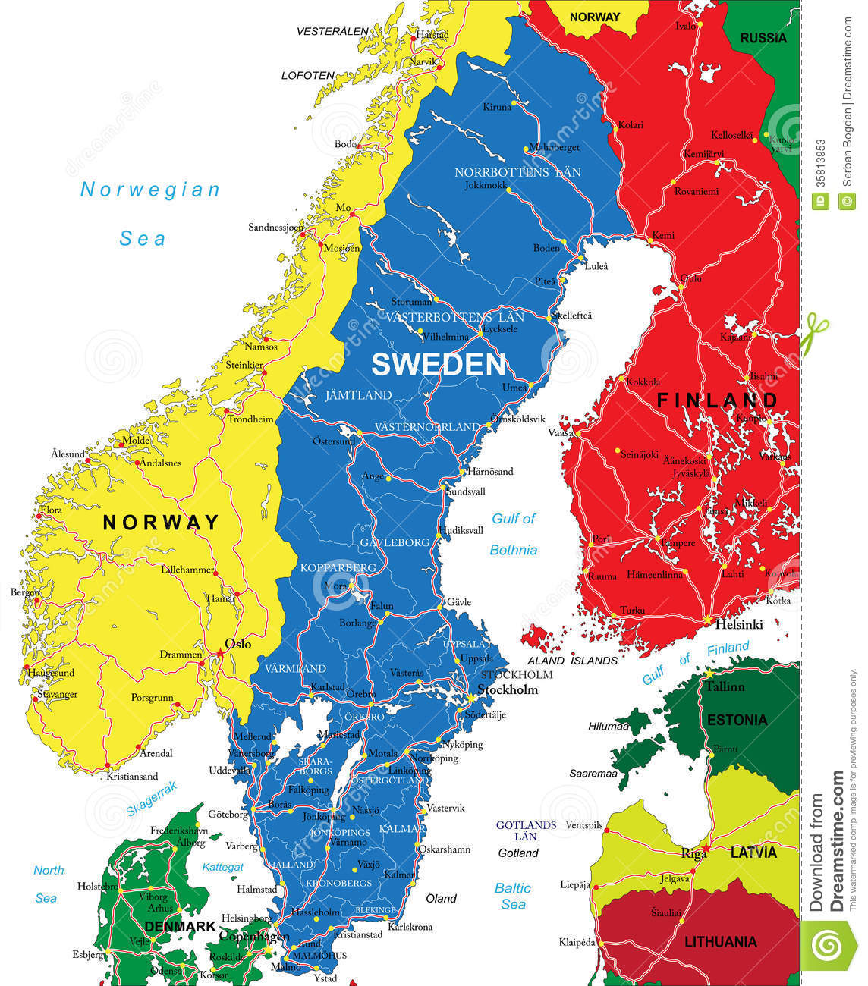
Location Capital
Politics
Weather
Official language
Religion
Swedish Krona
Holiday
- Part 2 (Swedish Economy)
Industry
Main Economy
- Part 3 (Ikea)
Industry
Founder Ingvar Kamprad
Product Introduction
Ikea food
Number of Employees
Worldwide Locations
- Conclusion
- Responsible Assignment
- Reference
- IKEA
Ingvar Kamprad → 創辦人
Elmtaryd → 創辦人成長的農場
Agunnaryd → 創辦人的家鄉

